|  |
| --- |
|  |



Atlas of Deprivation in Wales

Dr Robert Berry

countryside and community research institute

Project Title:

Atlas of Deprivation in Wales

|  |  |  |
| --- | --- | --- |
| **Start Date** 21st May 2020 |  | **Project Manager** Robert Berry |
| **Finish Date** xx Month xxxx |  | **Research Team** Robert Berry |
| **Duration** Xxxx |  | **Date of Report** xx Month xxxx |

When quoting this report   
use the following citation:

Author name initial (YYYY) Project Title, Report to   
Client Name. Countryside   
and Community Research Institute: Gloucester.

Executive Summary 4

1. Introduction 5

1.1 Why map deprivation? 5

1.2 The Welsh Index of Multiple Deprivation 5

2. Methodology 6

Methoody written for Guisers to replicate. Those not interested in technical dateails can skip straight to maps 6

2.1 Data acquisition and pre-processing 6

2.2 Mapping the data 6

2.3 Report Structure 6

2. All-Wales Maps 8

3. Local Authority Maps 9

|  |  |
| --- | --- |
| Figure 1 Single line figure reference | X |
| Figure 2 Double line figure reference Double line figure reference | X |
| Figure 3 Single line figure reference | X |
| Figure 4 Single line figure reference | X |
| Figure 5 Single line figure reference | X |
| Figure 6 Single line figure reference | X |
| Figure 7 Single line figure reference | X |
| Figure 8 Single line figure reference | X |

## Executive Summary

#### Subtitle (Heading 4)

Body copy volupie uuntiore plitasp ererem et quaerorro ipist io molum consequ odicit alibus dolupiet qui te eum andipsunto cone stincte et quoditi osamentia net, solorep rempor accaess itianie ntemporum nons eri busdam sit audae volupienim labore verita vitem est, vel escia cons. Nam etur? Quist laccus quuntiore plitasp ererem et.

Body copy volupie ndaecus ipidus excearunt quaessitaquo id quo eaqui con seri rem. Nam etur? Quist laccus quuntiore plitasp ererem et quaerorro ipist io molum consequ odicit alibus dolupiet qui te eum andipsunto cone stincte et quoditi osamentia net, solorep rempor accaess itianie ntemporum nons eri busdam sit audae volupienim labore verita vitem est, vel escia cons. Nam etur? Quist laccus quuntiore plitasp ererem et.

Body copy volupie ndaecus ipidus excearunt quaessitaquo id quo eaqui con seri rem. Nam etur? Quist laccus quuntiore plitasp ererem et quaerorro ipist io molum consequ odicit alibus dolupiet qui te eum andipsunto cone stincte et quoditi osamentia net, solorep rempor accaess itianie ntemporum nons eri busdam sit audae volupienim labore verita vitem est, vel escia cons. Nam etur? Quist laccus quuntiore plitasp ererem et.

* Bullets
* Bullets
* Bullets
* Bullets

Body copy volupie ndaecus ipidus excearunt quaessitaquo id quo eaqui con seri rem. Nam etur? Quist laccus quuntiore plitasp ererem et quaerorro ipist io molum consequ odicit alibus dolupiet qui te eum andipsunto cone stincte et quoditi osamentia net, solorep rempor accaess itianie ntemporum nons eri busdam sit audae volupienim labore verita vitem est, vel escia cons. Nam etur? Quist laccus quuntiore plitasp ererem et.

## 1. Introduction

### 1.1 Why map deprivation?

Body copy volupie ndaecus ipidus excearunt quaessitaquo id quo eaqui con seri rem. Nam etur? Quist laccus quuntiore plitasp ererem et quaerorro ipist io molum consequ odicit alibus dolupiet qui te eum andipsunto cone stincte et quoditi osamentia net, solorep rempor accaess itianie ntemporum nons eri busdam sit audae volupienim labore verita vitem est, vel escia cons.

### 1.2 The Welsh Index of Multiple Deprivation

As above, People who live in deprived areas may not be deprived and those living in areas with relatively low levsl of deprivation many be deprived. Low depriuavtion not the same as being affluent.

## 2. Methodology

### Methoody written for Guisers to replicate. Those not interested in technical dateails can skip straight to maps

### 2.1 Data acquisition and pre-processing

<http://www.statsmapsnpix.com/2016/02/more-automated-mapping-in-qgis-using.html>

Data

* WIMD shapefiles from Lle
* Local authority shapfile – Lle
* LSOA to gfoegpahy (UA) lookup file from StatsWales

Methods notes

* Download LSOA rank from specifying “decile”- <https://statswales.gov.wales/Catalogue/Community-Safety-and-Social-Inclusion/Welsh-Index-of-Multiple-Deprivation/WIMD-2019/welshindexofmultipledeprivation2019-by-rank-decileandquintile-lowerlayersuperoutputarea>. Data prepped in Excel to remove superfluous rows and columns - 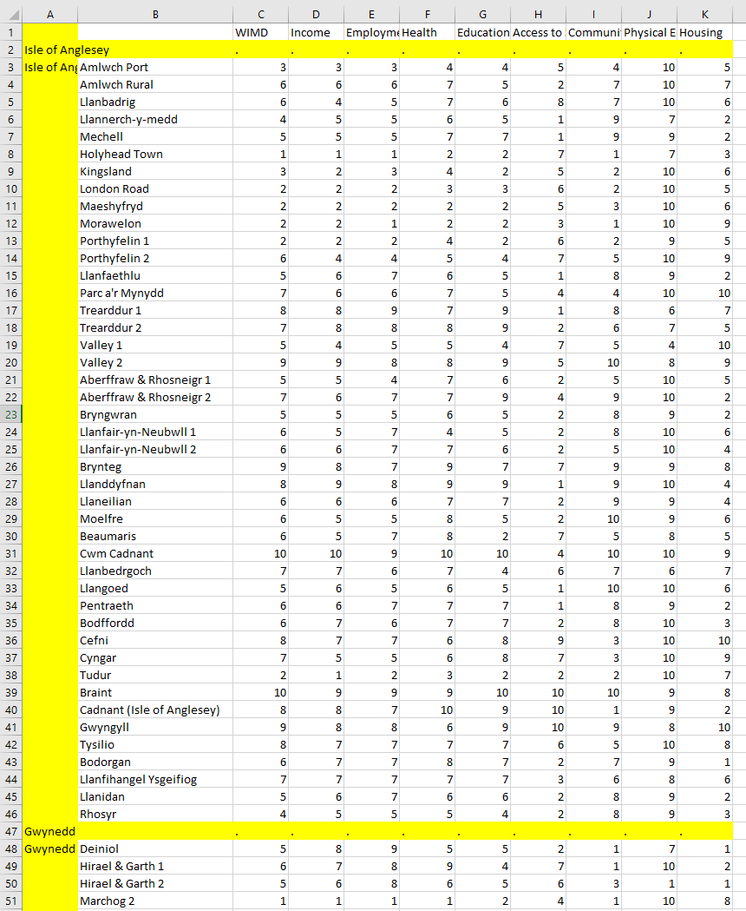
* Spatial data for LSOAs downloaded from Lle - <https://lle.gov.wales/catalogue/item/LowerSuperOutputAreas/?lang=en>
* The above data only had name only, but spatial data on deprivation by LSOA downloaded from LLe included columns name – ideally these would be linked by a concise code as less room for error.
* Join LSAO – LA lookup to shapefile – create separate file then dissivle for LA boundaries.
* J

### 2.2 Mapping the data

### 2.3 Report Structure

* Bullets
* Bullets
* Bullets
* Bullets

Body copy volupie ndaecus ipidus excearunt quaessitaquo id quo eaqui con seri rem. Nam etur? Quist laccus quuntiore plitasp ererem et quaerorro ipist io molum consequ odicit alibus dolupiet qui te eum andipsunto cone stincte et quoditi osamentia net, solorep rempor accaess itianie ntemporum nons eri busdam sit audae volupienim labore verita vitem est, vel escia cons.

Figure 1

Figure 2

## 2. All-Wales Maps

## 3. Local Authority Maps